Chapter 4

The Process of Parliamentary Enclosure

A traveller passing through the Wantage area in 1800 would have seen a patchwork of enclosed and unenclosed hamlets. Land in the north of the four parishes had long been enclosed. In this part of the region farmers were able to specialise in livestock production. Again, in the south of the parishes, eighteenth century enclosures had made it possible for farmers convert relatively poor downland sheepwalk to a more productive arable/sheep husbandry. The adjoining parishes of Farnborough, Letcombe Bassett, and Childrey were enclosed through acts of Parliament in the 1770s. The enclosure of Farnborough and an agreement to enclose an area of common grazed by both Farnborough and Betterton may have encouraged Matthew Wymondsold to suggest, unsuccessfully, that East Lockinge should enclose in 1778. It was another several decades before there was sufficient incentive and agreement for any of the four parishes around Wantage to begin the process of petitioning Parliament. In the ten years between 1801 and 1811, however, 73.5 per cent of the remaining area of open field, common meadow, and waste and commons was enclosed. The first parish to complete the process was West Challow in 1803. Letcombe Regis and East Challow followed in 1804, Wantage and Grove in 1806 and Ardington in 1811. In doing so, they joined part of a widespread, national movement to end traditional agriculture. East Lockinge and Charlton were slower to enclose (see Appendix 1). On the 23rd June 1810 John Pollexfen Bastard wrote the following to the Rev Dr Isham at All Soul’s College, Oxford
Under the idea that the same advantage would accrue to inclosing Lockinge, as has to the neighbouring Parishes which have been recently inclosed, I venture to propose the Measure to you. Certain it is that the Tithe of the common field will benefit considerably independent of the consideration of the Quantity of Downs, furze, and waste that will be brought into cultivation, and which is now worth scarcely anything to the Tithe.
This proposal, however advantageous it may have been, came to nothing and the remaining 25 per cent of land in East Lockinge were not enclosed until 1853. Charlton, enclosed in 1868, was the penultimate enclosure in Berkshire. Both of these enclosures were carried out under the General Act of 1845.

Obtaining an Act to Enclose

Once several in a parish had decided that enclosure was a viable proposition and that it was preferable to do so by act rather than by private agreement, the first official step was to petition Parliament for leave to present a bill. Because enclosure was expensive, the decision was a major one for the parish. Arthur Young, a well-known agriculturalist selected to report on parliamentary enclosure by the Board of Agriculture in 1808, found the average cost of all parliamentary enclosures to 1800 was slightly more than £1650. This could vary widely. At Longcot the 1797 enclosure took one year and cost £3153 5s 3d, an average of £1.77 per acre. The 1818 enclosure at Great Shefford took six years and cost £1397 10s averaging £2.62 per acre. Even the cost of obtaining an act was high. The average for all acts up to 1800 was £497. At Englefield, where the enclosure was particularly complex and lasted twenty years, the cost of obtaining the act to enclose thirty-four acres was £563 19s 5d. At Longcot in Shrivenham enclosure cost £525 16s 10d, and at Great Shefford £510. Before incurring the cost of obtaining an act, it was wise to make certain that a majority – generally at least two-thirds by value of landowners were in favour of the enclosure. This could either be done through personal contact with the owners themselves, or by using a representative. Often a future enclosure commissioner would be asked to canvas the owners and then guide the parish through the drafting of the bill. If there appeared to be sufficient support, a bill was prepared. Notice was then given to the people of the parish of the intention to petition Parliament for leave to submit a bill. The interested parties promoting the bill signed the petition (see appendix I). At Wantage and Grove twenty-nine owner signed the petition; at Letcombe Regis and East Challow twenty-three petitioned; at West Challow there were ten signatories and at Ardington nine. The East Lockinge and Charlton awards do not provide details of the petitioners. However, an unsuccessful petition from East Lockinge had only one signature, that of John Pollexfen Bastard.

The desire of a major landowner to enclose was not always enough to get a bill through Parliament. Before their successful enclosure acts were passed, owners from Letcombe Regis, East Challow, Wantage and Grove and East Locking petitioned Parliament and then, for no stated reason, failed to bring in a bill (see Appendix II). The efforts to enclose the parish of East Lockinge are particularly interesting. From the time he began to build his estate in the Lockinge area, Matthew Wymondsold intended to enclose. However, he so alienated the Rector of East Lockinge, who also happened to be the Warden of All Soul’s College, Oxford, that his efforts were continuously thwarted. In 1778, after his death, his widow along with the rector and others in the parish petitioned for a bill. Again in both 1811 and 1812, his widow’s second husband, John Pollexfen Bastard, first with others and then alone petitioned Parliament. None of the petitions were ‘proceeded in’. It would seem that in each case the question of how to compensate for the tithes was a major, and apparently insolvable, problem until in the 1840s when the commutation of the tithes finally resolved this contentious issue.

Before the General Inclosure Act of 1801, drafting an enclosure bill was technically difficult; failure to comply with the standing orders of Parliament could delay the proceedings and increase cost. The 1801 act facilitated enclosure by setting out clauses that would be acceptable and thereby providing a template for each private act. It was essential to comply with the Standing Orders of the House. At West Challow, for example, public notice of the intention to petition Parliament was not given, possibly because there was general agreement about the enclosure. On presentation of the petition it was ordered that the matter should be examined further. The committee found ‘that the Standing Orders of the House of Commons, relative to the Bills of Inclosure, had not been complied with’. However, they decided that since ‘it appeared to the Committee, that all the Parties interested in the Lands intended to be inclosed are consenting thereto’, more time would be allowed to give the necessary notice. Notice was then read on three consecutive Sundays in the parish church at Letcombe Regis and the chapel at West Challow. Leave was given to bring in the bill. Anyone opposed to the bill could submit a counter-petition that would be heard by the committee. This occurred during the passing of the act for Ardington. John Pollexfen Bastard appears to have had some last minute reservations about the bill. His agent submitted a counter-petition. However, there is no evidence of him taking the matter further, and the bill resumed its course through Parliament. Once approved by the committee, the bill was presented to Parliament where it received its first and second, and third readings, was agreed by the House of Lords, and, finally, received Royal Assent (see Appendix II).

The acts for West Challow, Letcombe Regis and East Challow, Wantage and Grove, and Ardington were all passed under the General Inclosure Act of 1801. While this act facilitated the process of enclosure, it did not eliminate the need for a separate act for each enclosure. In 1836 an act for facilitating the enclosure of the open arable fields was passed. A further act in 1840 widened the scope of the 1836 act to include land other than arable. These acts made it possible, if there were agreement of two-thirds in number and value of the proprietors, to appoint enclosure commissioners to act without going through Parliament. If seven-eights agreed, the proprietors could dispense with the services of the commissioners altogether. Another general enclosure act was passed in 1845 further simplified the procedure for obtaining an act. A standing Enclosure Commission was set up which, in turn, appointed assistant commissioners who undertook the work of enclosure. Both East Lockinge and Charlton were enclosed under this act.

The Choice and Nature of the Enclosure Commissioners

One of the most important decisions the proprietors had to make was who would represent them during the enclosure process. These men, variously termed arbitrators, referees, valuers, but most often commissioners, were, in fact, the architects of the post-enclosure landscape. Their powers were immense. Arthur Young called them ‘a sort of despotic monarch; into whose hands the property of a parish is invested, to recast and distribute it among the proprietors; and in many cases without appeal.’ Amongst their duties were the tasks of establishing the boundaries of the parish, determining the validity of each claim for an allotment of land at enclosure, assessing the quality of land in the parish, allocating land to each successful claimant, and establishing roads, bridleways, and footpaths. During the process of enclosure they took on the task of regulating the farming to ensure that land to be exchanged was not neglected or over-cropped. Selecting the right men for the task was important. So who were these men and what skills did they bring to the process?
Table 4.1 Commissioners acting in three or more Enclosure Awards in Berkshire
Commissioner | Residence | Number of Enclosures | Dates of Activity | Observations and other involvement
Davis, John* | Bloxham, Oxon | 34 | 1795-1818 | served as umpire
Barnes, George | Andover, Hants | 21 | 1801-29 | served as umpire and surveyor
Bushnell, William | Aston Tirrold, Berks | 16 | 1800-14 | served as umpire
Davis, Richard | Lewkorn | 11 | 1786-1813 | served as umpire; removed due to illness; died 1814
Smallpiece, George | Nr Guilford, Surrey | 8 | 1807-20 | served as umpire
Crabtree, Richard | Wokingham, Berks | 8 | 1813-27
Dixon, Henry | Oxford, Oxon | 7 | 1810-52
Lousley, Daniel | Blewbury, Berks | 7 | 1836-43
Trumper, John | Harefield, Middlesex | 7 | 1802-14 | served as umpire; died before completion of award
Watts, John | Sulgrave, N’ants | 7 | 1771-80
Wood, William Bryan | Brenhill, Wilts | 6 | 1845-64
Allin, John | East Hendred, Berks | 5 | 1801-12
Browne, Thomas | Cowley, Gloucs | 5 | 1771-77
Nockolds, Martin | Tring, Herts | 5 | 1803-32
Washbourne, Thomas E. | Westminster | 5 | 1836-53 | removed due to illness
Burton, Francis | Aynhoe, N’ants | 4 | 1772-77 | died before completion of award
Chapman, Thomas | Richmond Surrey & Middle Temple, London | 4 | 1814-27
Richardson, Richard | Lincoln’s Inn Field | 4 | 1801-15 | served as umpire
Brothers, John | Wykin, Warks | 3 | 1770-78
Driver, Edward | Whitehall, Westminster | 3 | 1814-60 | died before completion of award
Fuller, William Henry | Caversham, Berks | 3 | 1855-68
Hawkes, Francis | Reading, Berks | 3 | 1845-58
King, James* | Daventry, N’ants | 3 | 1777-80
Pinnell, John | Woolastone, Glos | 3 | 1776-94
Slade, John | Aston Upthorpe, Berks | 3 | 1811-29 | served as umpire
Stephens, John | Farnborough, Berks | 3 | 1758-80
Trinder, Daniel | Cirencester, Glos | 3 | 1825-43
* Two men of this named worked as commissioners in Berkshire
Source: Catalogue of Enclosures, BRO

Initially enclosure commissioners were closely associated with the enclosure. In 1736 at Inkpen and Kintbury there were three commissioners, Edward Hanson, gentleman of Hungerford, Roger Geater, yeoman of Kintbury, and Simon Rawlins, yeoman of Avingdon. All of these men lived locally. Because the act was simply a confirmation of an earlier enclosure and the enclosure was not controversial, only three referees were used. When a new enclosure was involved, it was normal for more commissioners, each representing the interests of an individual or a small group, to be named. Over time, if an interested party did not name someone known to him personally, he might use someone recommended to his from an earlier enclosure. By the 1770s commissioners had developed considerable expertise and were invited to act over a wide area. Thus in 1772 at Letcombe Bassett and Childrey, five commissioners – Francis Burton, gentleman of Aynhoe, Northamptonshire, Thomas Browne, gentleman, of Cowley, Gloucestershire, John Watts, gentleman, of Sulgrave, Northamptonshire, and William Freeman, gentleman, of North Kilworth in Leicestershire, and John Stephens, the only local man from the nearby parish of Farnborough, were named. William Freeman died in 1772 and was replaced by Thomas Harrison, gentleman, of Stoney Stratford, Buckinghamshire. Of these men Watts from Northamptonshire served on seven enclosures in Berkshire, Browne from Gloucestershire acted on five, Burton from Northamptonshire on four, and Freeman from Leicestershire on two (see table 4.1).
Fig 4.1 Enclosures worked on by John Davis and George Barnes in Berkshire
NB The dates worked are the period between act and award. The commissioner could be engaged in the period before and act and had not necessarily completed the work once the award was made.
Source: BRO Catalogue of Inclosures
With the passage of time the number of commissioners was reduced. Using a large number of referees helped to ensure that, within the limits of the procedure, a fair and unbiased enclosure took place. However, it was cumbersome. From 1774 a series of parliamentary standing orders were introduced to ensure greater equity and fairness in the proceedings. Increasingly the enclosure committee was composed of three men (no women are on record as having acted in this capacity in Berkshire), one selected by the Lord of the Manor, one by the holder of the tithes, and a third by all other proprietors. This could, and did, vary. At Letcombe Regis and East Challow in 1801, the Dean and Chapter of Westminster and their lessee Exuperious Turnor as Lord of the Manor selected William Bushnell of Aston Tirrold, and the other proprietors selected John Davis of Bloxham, Oxfordshire, and John Allin of East Hendred. At Ardington, John Davis was selected by William Wiseman Clarke, as the Lord of the Manor, and George Barnes by John Pollexfen Bastard and the other proprietors. If two commissioners were appointed and disputes arose, a third person could be appointed umpire. Where there was no anticipated problem with allocation of the land, only one commissioner was named. Thus in the Milton act in 1809 John Davis was the only commissioner and at Basildon in the same year William Bushnell was selected by all involved. While the men were chosen to safeguard the interests of one person or group, each swore an oath. The 1801 General Inclosure Act suggested the following:
I A.B. do swear, that I will faithfully, impartially, and honestly according to the best of my Skill and Ability, execute and perform the several Trusts, Powers, and Authorities vested and reposed in me as a Commissioner by the virtue of an Act for (Title of Act), according the Equity and good Conscience, and without Favour or Affection, Prejudice or Partiality to any Person or Persons whomsoever.

The office of enclosure commissioner was increasingly filled by men, often farmers or surveyors, who were turning the supervision of enclosure into a profession. Of the 113 commissioners named in known enclosure acts in Berkshire, 29 men were used for more than two enclosures of whom John Davis of Bloxham near Banbury was the most active (Table 4.1). Between 1797 and 1817 he was a commissioner for 34 awards, including those at West Challow, Letcombe Regis and East Challow, Wantage and Grove, and Ardington. He also acted as umpire on three occasions. Along side his work as a commissioner he was a farmer on a mixed farm of about 400 acres in Oxfordshire. George Barnes of Andover, Hampshire was the second most active commissioner in the county. By training, he was a land surveyor. On nine occasions, including the enclosures in West Challow and Ardington, he worked with John Davis. Between 1802 and 1829 he was a commissioner 21 times, umpire twice and surveyor twice. Both men served as commissioners in other parts of England. John Davis’ service as a commissioner took him all over southern and central England including work in Bedfordshire, Buckinghamshire, Gloucestershire, Huntingdonshire, Leicestershire, Northamptonshire, and Oxfordshire. In total he served on 101 enclosure commissions. George Barnes was particularly active in his native county of Hampshire where he worked on twenty-five enclosures. He also was a commissioner in Buckinghamshire, Dorset, Gloucestershire, Oxfordshire, and Wiltshire. In total he worked on sixty-two commissions. In many years each served on a number of concurrent commissions. In Berkshire alone John Davis worked on twelve commissions in 1803 and eleven in 1811. In 1810, 1811, and 1812 George Barnes served on thirteen commissions (see figure 4.1).

Cost was probably the main reason for limiting the size of the commission. At Ardington William Wiseman Clarke and John Pollexfen Bastard agreed to select only two commissioners specifically in order to save on the cost. The remaining proprietors agreed and the name of Mr Parson was taken off the commission. Work as a commissioner could be very lucrative. John Burcham of Coningsby, Lincolnshire acted as an enclosure commissioner at least sixty-nine times between 1801 and 1840. When he died in 1841 he left £600,000 in his will. John Davis justified his absence at meetings as a means of saving on expenses. However he was reputed to have been contentious about representing the interests of the person who had appointed him and he did make it a policy to attend whenever those interests were involved. On occasion his absence and caused problems. During the Ardington proceedings, Mr James Hall as representative for the Trustees of Lambourn Almshouse claimed expenses for attending enclosure meetings that had to be abandoned because no commissioners were present. Evidence from the minutes kept by the commissioners at Letcombe Regis shows that there was no quorum on at least five occasions. On each occasion John Davis was absent (see Appendix III).

The Work of the Commissioners

Once the act was obtained and the commissioners selected, the real work could begin. The precise range of their activities was determined by the specific private act. Generally, however, their work followed a well-established pattern. At the first meeting the commissioners were sworn in, the clerks, surveyor, and bankers were appointed. About the same time the parish was viewed so the course of husbandry could be determined. This was essential to ensure a smooth transition between open field husbandry and farming in severalty. When the decision to enclose was taken, the farmer no longer had a stake in the land he was farming. Contemporary agriculturalist and advocate of enclosure, Arthur Young, explained the mentality of the farmer during this difficult time:
From the first starting the project of an enclosure act to the final award, has, in numerous cases, taken two, three, four, and even five or six years; their management is deranged; not knowing where their future lands will be allotted, they save all their dung till much of it is good for little; they perform all operations of tillage with inferior attention; perhaps the fields are cross cropped and exhausted, and not well recovered under a course of years.
In order to curb the worst excesses, the enclosure commissioners were given control of agriculture during the period between the act and the award. The following notice giving typical directions for agriculture at West Challow appeared in the Reading Mercury on 20 September 1802:
The Commissioners do hereby direct that the lands within the above Hamlet, lately planted with a hitching crop, and which shall come in course to be planted with wheat, in the ensuing season, shall be forthwith ploughed in an husbandlike manner, by the respective occupiers thereof.
The General Inclosure Act of 1845 included fines that could be imposed on farmers failing to comply with the commissioners’ orders. There could be a fine of £5 per acre for cross-cropping or withholding manure, and a £10 fine for each of any of the other specified offences. To minimise the disruption, holdings could be allocated before the award was executed. At Letcombe Regis and East Challow, some allotments were set out to make it possible for the proprietors to plough in late October 1802. On 5 April 1803 notice was given that rights of common ceased and the land was ‘divided, allotted, laid in severalty, and inclosed’. The award was not executed until 5 October of that year (see Appendix III)

After the smooth running of the agricultural calendar was assured and the people involved to run the enclosure appointed and sworn, the task of allocating land could be started. Two surveys had to be made. The first was a simple plan of the land to be enclosed along with any old or ‘ancient’ enclosed land that was to be exchanged. If there were any doubts about the location of parochial boundaries, a meeting was called to perambulate the boundaries and notice was sent to all relevant churches and chapels. The second survey was made to determine the value, condition, and potential of the land to be divided. Henry Homer, writing on the division of land at the time of enclosure in the mid-eighteenth century explained the process:
There should be a critical examination of the soil, as well as of the herbage which it produced, an enquiry into its latent qualities, whether it contains anything noxious to any species of profitable cattle? Whether particular seasons are not adapted to it, and how far it is affected by the present? What management it had been under for a course of years past, and the like? To these should
be added a due regard to its situation for convenience; a consideration of the different expense of inclosing according to its greater or less intrinsick value.

The valuation was particularly important in areas of long narrow parishes like those extending from the Vale of the White Horse up on to the Downs. Not only was there the variation from the heavy clays of the north to the thin chalks of the south, but there was also variation east to west. The parishes of Ardington and East Locking had a greater proportion of good quality loam than Letcombe Regis and Wantage. The tithe commissioner inspecting the parish of Ardington found ‘so considerable a variety of soil that I could not feel confident in any estimate I might make without the means of forming an accurate notion of the respective extent of the various soils.’ Again in Ardington, an assessment of the varying quality of land on the Lambourn Almshouses Estate found that the rent of the best arable was more than the meadowland but that the worst was valued at only about 60 per cent of the best. Such variety made the allocation of land in the area particularly difficult. The presence of a local commissioner like John Allin of East Hendred to compliment the experience of John Davis and George Barnes can only have facilitated this part of the Letcombe Regis enclosure.

Once the enclosure commissioners knew both the quantity and quality of the land available, they could begin the task of redistributing the land in the open fields, meadows, wastes, and commons (see fig. 4.2). This was done in three stages. First to be marked out were the roads, footpaths, and bridleways, the village gravel and chalk pits needed to make and maintain the roads, drainage work that was of benefit to the community as a whole, allocations for the poor, and so forth. The second allocation was to compensate those holding abstract rights in the parish – the lord of the manor for loss of his ownership on the soil of the waste and common and, the tithe owner if, as in West Challow the tithe was to be commuted as part of the enclosure. The remaining claimants formed the third group to be allocated land. Within this group the General Inclosure Act of 1801directed that commissioners should have ‘particular regard for the Convenience of the Owners of Proprietors of the smallest Estates’.
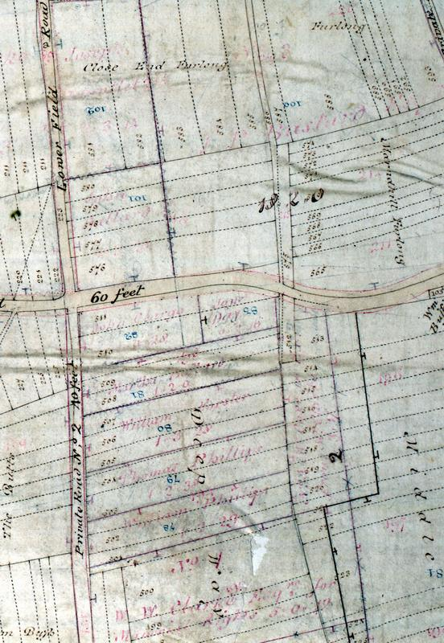
The examination of claims went on throughout the other work of the commissioners. At Letcombe Regis and East Challow, for example, the first meeting was on 28 July 1801, claims were invited from 13 September of that year. Various complaints continued to be heard until early in 1804. The award was executed on 6 October 1804 (see Appendix III). For the other parishes it is a safe assumption that the long gaps that often occurred between the newspaper announcements were filled examining claims and setting out allotments. The task of examining the claims was laborious and often complex. Each person submitted a statement of the area held in the open fields and in the meadow along with the right to common associated with their holding along with the type of tenure under which the land was held. If they had supporting documentation, this too was produced. A particularly detailed minute book kept at Great Shefford illustrates the problems that the commissioners faced when dealing with claims. The Lord of the Manor, the Marquis of Downshire, owned most of the land in the parish. His agent objected to a number of the claims submitted by others in the parish. Generally the objections related to the number of animals that could be grazed on common land in the parish. Hannah and Catherine Westbury held several acres of copyhold land belonging to the Marquis of Downshire. They also occupied a holding of unspecified tenure (but most likely to have been a leasehold or let at a rack rent) containing 33 acres 1 rood 4 perches in the North and South Fields This had been purchased by the Marquis of Downshire, possibly in an effort to further consolidate his estate, shortly before the enclosure began. The claim by the sisters to the commissioners was for a copyhold of 1½ acres in the North Field, the same amount in the South Field together with the right of common for one cow and an unspecified number of sheep. The agent to the Marquis of Downshire objected. He noted that only 2 acres 1 rood and 22 perches were held by the Westbury sisters, and, as a consequence, only rights to ‘one half cow common on the downs and the commons in the fields according to the quantity in respect of other lands having right of common therein’ was associated with the holding. Catherine Westbury then conceded that the former custom was to allow one cow on the Downs in every year but that under the present stint she was limited to a cow every other year. However, she also noted, somewhat belatedly, that she was the tenant on another holding that contained 40 acres in the open fields to which belonged common grazing on the downs for 4 cows and, she believed, 40 sheep. Her brother, before his death had stocked sheep on the breach of the common fields but that she had not done so and, although she considered that she retained the right, she did not know the number permitted. She produced both documentary evidence and witnesses to substantiate her claim. One witness testified that two years earlier in 1810 the Westburys had grazed two milch cows and a heifer on the down and in 1811 one milch cow, one barren cow, and one horse. Other witnesses, including a brother living in another parish, provided further evidence. The evidence of the manor hayward supported the Marquis of Downshire. Although the outcome of the claim and counter-claim was not recorded, when the allocation was announced, Catherine ‘expressed herself satisfied with her allotment’. She did ask that her allotment ‘be laid in the South Field adjoining and in front the House belonging to her Holding.’ In the award of 1818, Hannah Westbury received 2 acres and 24 perches adjacent to her homestead in the South Field. No mention was made of the larger holding which, unless copyhold, may have been recorded as part of the allocation to the Marquis of Downshire. It is also possible that Hannah, by this time the only remaining name on the copyhold tenancy, had only the smaller holding.
Fig 4.2 This working enclosure map of Ardington illustrates the main tasks of the enclosure commissioners. First they had to locate and identify the owners of the common land (black dotted lines) and any ancient enclosures. Once this was complete, roads could be widened and straightened and new roads plotted. Finally the new allocations of land (black solid lines with the proprietors named in red) were drawn. Responsibility for fencing the land was indicated by a T on the boundary.
Source: BRO D/EL P1

Although the survival of claims is unusual, the Hedge Family Estate records include a claim for 29½ acres of arable land, 4 acres of meadow and common pasture for one cow and an indefinite number of sheep and a counter-claim objecting to the claim for the flock made in the 1868 enclosure at Charlton. At least one and sometimes several printed abstracts of the claims were circulated and objections or counterclaims invited. Because the failure to object to a controversial claim might require court action to reverse, these claim abstracts have survived in estate and solicitors collections. One such abstract from the Letcombe Regis and East Challow enclosure has a hand-written note at the bottom:
Sir, You are requested to inspect the Abstract and if you have any objection to and of the claims you are desired to attend and make the same to the Commissioner on Friday the 28th day of May next at the King’s Head Inn in Wantage at eleven o’clock in the forenoon. I am sir your h[onoura]ble serv[ant] Jn Barr, Wantage April 3 1802.

Such vigilance by the owners was essential. At Ardington, the claim made by the Rev. Richard Coxe was published in an abstract from January 1811. He claimed:
Several parcels of Arable Meadow and Pasture Land situate lying and being in The Common Fields of Ardington containing together by Computation 118 A[cres] in the occupation of John Clargo.
Also commons for twelve horses 18 cows 6 calves and 180 sheep in all the commons and commonable places of Ardington
Also commons for 141 sheep on the Downs called Wether Down with William Wiseman Clarke, esq.
This land was actually leased from the trustees of the Lambourn Almshouses and should have been claimed as such in conjunction with the charity. While it was not in the remit of the commissioners to determine title to land, the matter appears to have been brought to the attention of the charity by John Davis, selected to act as commissioner not by the ‘other proprietors’, but instead by William Wiseman Clarke. The allegation that Coxe had falsified the claim was denied but evidence from the Abstract would seem to support it. Without the attention to detail paid by John Davis, the lack of vigilance by the charity could have resulted in them having to go to court to reclaim the land. After the experience, they appointed James Hall to act as their agent for the land in Ardington.

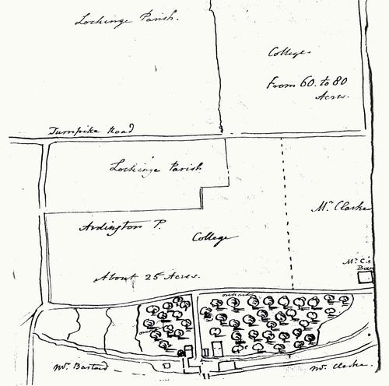
When allocating land the commissioners were charged with creating consolidated, convenient, and economically viable holdings. They had wide powers to determine the distribution of the land, but there were several things that they had to consider. Each claimant was invited to submit the desired location of land for his or her allotment, and as far as possible they took this into account. They were limited by the clauses in the act. This might require the commissioners to redistribute old enclosed land or to allocate land in lieu of tithe payments. The commissioners had to keep the enclosure and its consequences as inexpensive as possible. Where it was feasible holdings were placed near the homestead in the village. This
was not always possible to achieve. In principle, each proprietor was given an allocation of each type of land – arable, meadow, and common and waste. Because the land in the long narrow parishes around Wantage varied from the north to the south, it was particularly difficult to include all areas in a consolidated allocation. Whenever possible the smaller holdings were located near the homestead of the claimant. The holdings of the larger proprietors were then arranged around the smaller enclosures. They were rarely in a single unit. Generally each person received an allotment of arable and another in the meadow. Because of its inferior quality, downland tended to be distributed amongst the larger proprietors.
Fig. 4.3 The remit of the enclosure commissioners was to create consolidated holdings located conveniently near to the land owned in the village. The trustees of Lambourn Almshouses produced this sketch map of the land they desired. Unfortunately the allocation to the two principal owners made this allocation impossible.
Source: BRO D/QI C14

As far as possible the commissioners met the requests for land from the smaller claimants before those for whom consolidation and convenience were less important. This could not always be done. Again at Ardington, James Hall, the agent appointed by the Lambourn Almshouses, was frustrated in his efforts to obtain the land he felt best suited the interests of the charity. The estate belonging to the almshouses was centred on a mill and several orchards on the southwest side of the village. Ideally, the about 25 acres of land for their enclosed holding would have been located in the West Field (immediately north of the orchard in the sketch map – fig. 4.3) or in the Upper Field (immediately south) and a further 60 to 80 acres in the Lower Field (across the turnpike). Unfortunately, this arrangement was not possible. Under an unusual clause in the Ardington Act, John Pollexfen Bastard and William Wiseman Clarke had already secured Upper Field for themselves. Clarke also claimed the West Field as an old enclosure not to be allocated. James Hall produced several aged residents of the village who gave evidence that the Upper West Field and the Lower West Field had been fed several times with common stock at the breach of the field within the last 20 years. However, the commissioners decided that this right was not regularly exercised so they were bound to take the field as being land in severalty.

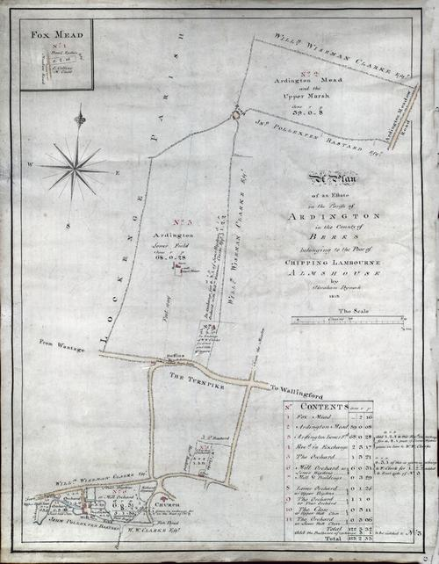
A second problem for the Trustees was the exchange of old enclosed land to be made between land belonging to the Lambourn Almshouses and William Wiseman Clarke. As with the allocation of the communal land, the power of the commissioners to force the exchange could be extensive. At Letcombe Regis, for example, their say was final. At Ardington, the act provided for recourse to court if an owner was particularly dissatisfied, but this would increase the cost of the enclosure. The exchange between the trustees for the Lambourn Almshouses charity and Clarke was for Great and Little Jiggers, 2.76 acres of riverside meadow and for 1.86 acres of arable land in the Lower Field belonging to William Clarke. The Trustees were not surprisingly dissatisfied with the exchange. In a memo of 23 January 1811 James Hall noted:
I went to Wantage to represent the inadequacy of the exchange of arable land for Jiggers, I was told it could not be remedied and was in the commissioners estimation right as it stood; and that Mr Clarke had been there the day before saying that in his mind the exchange was fair and reasonable, whereas on Monday, he told me there were 5 acres given for the Jiggers…
The Trustees could not approve of the exchange and Hall was asked to meet with the commissioners again. At this meeting and George Barnes acknowledged the mistake and promised to alter it. The area in the arable field was increased by an acre to 2.86 acres. This was contiguous with the other arable land allocated to the charity and, on Hall’s recommendation, it was accepted by the Trustees. The land awarded to Richard Coxe, Lessee of Lambourn Almshouse was essentially that requested. It consisted of 68a.0r.28p in the Lower Field, 39a 0r 8p in Upper Marsh and Meadow, 2r 16p in Ardington Meadow, and an exchange with William Wiseman Clarke for 2a 3r 17p in the Lower Field. These are shown on a slightly later map of the Lambourn Almshouse Estate (see fig 4.4)
Fig. 4.4 The Post-Enclosure Lambourn Almshouses Estate in Ardington shows the compromise made by the trustees of the Lambourn Almshouses. although in principle the needs of the smaller landowners were to be met first, at Ardington special clauses in the act along with an earlier contested enclosure limited their choice. The land allocated was less compact and convenient than would have been the ideal.
Source: BRO D/QI P3

After the complexities of dividing and allocating the land in a parish had been resolved, a draft award was eventually made available for inspection. Minor alterations to claims and private roads and paths were made. Finally the
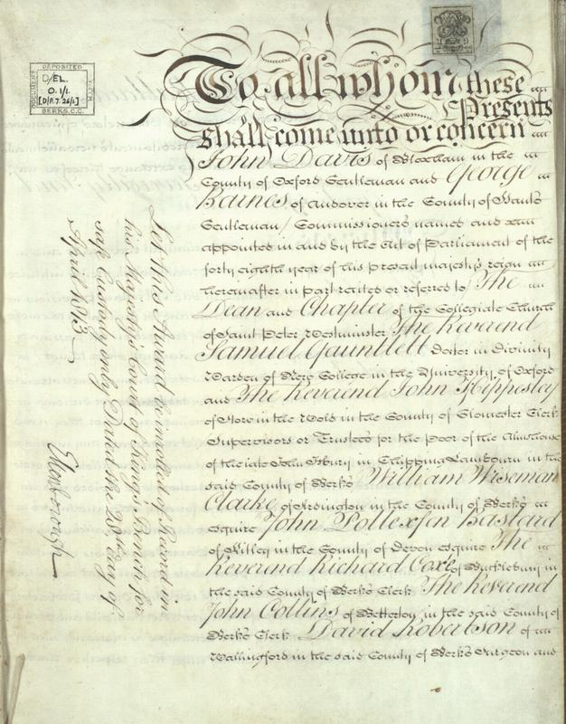
award was executed and deposited (see fig. 4.5). Although the commissioners continued to be involved with financial matters concerning the enclosure, it was essentially complete. The land of the parish was now farmed in severalty. In their work enclosing the parish, the commissioners had remodelled the countryside. John Davis, George Barnes and the others were, in reality, the architects of the post-enclosure landscape.

Fig. 4.5 Enclosure Award for Ardington, 1811
Source: BRO D/EL/ 01/1

MERL BERKS 43/1/5
Young, 1808, 98; The passing of the General Inclosure Act in 1801 was expected to reduce this by creating a template on which future acts could be based. However, it is uncertain that the act had much impact on cost of enclosure.
BRO D/EEl E8; BRO D/ED E13A
Young, 1808, 98
BRO D/EBy E19/2; Wordie 62-3
BRO D/EEl E8; BRO D/ED E13A
Journal of the House of Commons, LXVII, 69
Havinden, 1999, 7
Journal of the House of Commons, LVII, 150
Journal of the House of Commons, LVII, 212
Journal of the House of Commons, LVII, 212
Journal of the House of Commons, LVII, 229; 354
6&7 Wm IV c.115 (1836); 3&4 Vic. c.31 (1840); for a further discussion of the legislation see Tate, 1967, 129-37
Tate and Turner, 31-2
Young, 1808, 61
Tate, 1967, 129
Tate, 1967, 109-10
41 Geo. III c.109 (1801)
Tate, 1967 108-9
There were at least five commissioners named John Davis, several were related, working as enclosure commissioners. Information supplied by John Chapman
Young, 1813, 93-5: Turner, 1971, 175-7; Turner, 1977, 127-8
Information supplied by Dr John Chapman
BRO D/QI C14
Tate, 1967, 112
BRO D/QI C14
Young, 1808, 31
Reading Mercury, 20/9/1802
8&9 Vic., c.118, (1845)
For a more detailed account of the valuation process and the decisions resulting from it see Gonner, 77-82
Homer, 48-9
PRO IR18/ 13196 & 13096
PRO IR18/ 13096
BRO D/QI C14
41 Geo. III c.109 (1801)
BRO D/ED E13A
BRO D/EH E24
BRO D/EEl E9
BRO D/QI E10
BRO D/QI C14
Yelling 135
BRO D/QI C14
BRO D/QI C14
BRO D/QI C14
BRO D/EL/O1/1

